# **Main Enclosure Block Validation**

**Block Champion: Astrid Delestine**

**Date: Dec-06-2023**

## **1. Description**

The main enclosure protects the main board, the sensor control, and the screen. Due to the nature of the proximity to water, this is necessary. This enclosure cannot block user access to the screen.

## **2. Design**

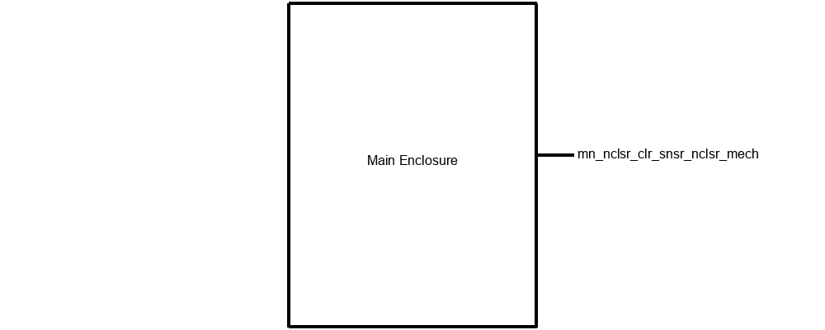

The design includes a box-shaped enclosure made of PETG. It accommodates the main board, screen, and associated circuitry. It interfaces with a similar enclosure for a color sensor.  
[INSERT SEVERAL CAD MODEL RENDERINGS]

## **3. General Validation**

The selection of PETG material for the enclosure aligns with the requirement for proximity to water, given its water-resistant properties. The design ensures the protection of internal components while enabling user interaction with the screen, meeting the specific needs of the system.

## **4. Interface Validation**

| **Interface Property** | **Why is this interface this value?** | **Why do you know that your design details for this block**  **above meet or exceed each property?** |
| --- | --- | --- |
| **mn_nclsr_clr_snsr_nclsr_mech : Output** | | |
| Fasteners: friction | The use of friction-based fasteners ensures a secure and stable connection between enclosures, facilitating easy assembly and disassembly for maintenance purposes. | The design specifies the use of friction-based fasteners explicitly to ensure a secure and stable connection, enabling easy maintenance and disassembly. |
| Other: Material: PETG | PETG material provides water-resistant properties, suitable for the proximity to water as required for the enclosure. | The material chosen (PETG) offers water-resistant properties, meeting the requirement for use near water. |
| Tensile strength of >= 10MPa | The PETG material chosen for the enclosure has a tensile strength exceeding 10MPa, ensuring durability and structural integrity under tensile forces. | Material testing confirms that the PETG used in the enclosure has a tensile strength exceeding the specified value, guaranteeing its durability. |

## **5. Verification Plan**

1. Verify the compatibility and alignment of the main enclosure with the circuit board and screen.
2. Conduct tests to ensure the PETG material meets the specified water-resistant properties.
3. Test the friction-based fasteners for their strength and ease of assembly.
4. Apply forces exceeding 1N to the enclosure to validate its ability to withstand shear forces.
5. Ensure seamless integration and connection between the main enclosure and the color sensor enclosure.

## **6. References and File Links**

[Ultimaker_PETG_TDS.pdf (dynamism.com)](https://www.dynamism.com/media/catalog/product/pdf/Ultimaker_PETG_TDS.pdf)

## **7. Revision Table**

| 12/6/2023 | Initial Draft |
| --- | --- |
| 12/7/2023 | Completed Draft |

# **Main Board Block Validation**

**Block Champion: Astrid Delestine**

**Date: Dec-06-2023**

## **1. Description**

**Delete Me:** This is the contents of your block description field in the Block diagram tool. You can expand here instead of the tool but it is best to add content to the webtool; not just the submitted document.

The module is responsible for connecting all the various electrical components. It contains the code and screen data.

## **2. Design**

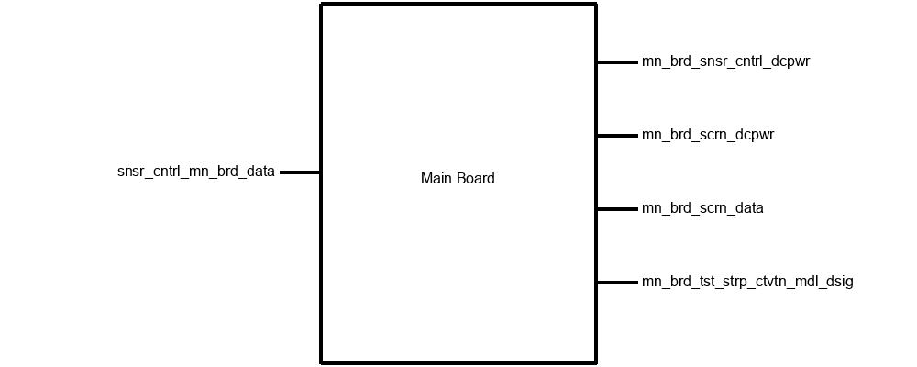

The block incorporates an Espressif ESP32-WROOM-32E microcontroller, facilitating connections via I2C for the color sensor and screen. PWM is utilized to control the motor, while direct port connections manage the buttons on the main circuit board.

[INSERT SEVERAL f360 CIRCUIT DESIGNS HERE]

## **3. General Validation**

The design was chosen to meet specific system needs, enabling seamless integration of diverse electrical components. The selection of the Espressif ESP32-WROOM-32E provides a versatile microcontroller platform, allowing for efficient communication with the color sensor, screen, motor, and buttons. By employing I2C for the color sensor and screen, PWM for the motor, and direct port connections for the buttons, the design ensures compatibility and effective control of each component within the system.

## **4. Interface Validation**

**Delete Me:** This section is about why the contents of the **design section** you presented above meet each of the properties. The table provided has 3 columns, be sure that you keep these three columns and complete them fully. Please adjust the column widths in your final document to best use whitespace.

| **Interface Property** | **Why is this interface this value?** | **Why do you know that your design details for this block**  **above meet or exceed each property?** |
| --- | --- | --- |
| **mn_brd_snsr_cntrl_dcpwr : Output** | | |
| Inominal: 210 uA | The sensor requires a nominal current of 210 uA for its operation. | The design ensures that the block provides a nominal current output within or exceeding the specified range, guaranteeing proper functioning and power supply to the sensor. |
| Ipeak: 300 uA | The sensor may have peak current requirements up to 300 uA. | The design ensures that the block can handle peak current output of up to 300 uA, which may occur during certain sensor operations or functionalities. |
| Vmax: 2.0v | The sensor operates within a maximum voltage of 2.0 volts. | The design ensures that the block output voltage remains within or exceeds the specified maximum limit of 2.0 volts, maintaining safe and optimal operating conditions for the sensor. |
| Vmin: 1.7v | The sensor needs a minimum voltage of 1.7 volts for functionality. | The design ensures that the block output voltage does not fall below the specified minimum limit of 1.7 volts, ensuring the sensor receives adequate power for proper operation. |
| **mn_brd_scrn_dcpwr : Output** | | |
| Inominal: 1A | The screen necessitates a nominal current of 1A during regular use. | The design ensures that the block provides a nominal current output of 1A or higher, meeting the screen's power requirements for typical operation. |
| Ipeak: 1.2A | The screen may require a peak current of up to 1.2A in specific cases. | The design accommodates peak current demands of up to 1.2A, ensuring that the block can handle higher power needs during specific screen functionalities or instances. |
| Vmax: 5v | The screen operates within a maximum voltage of 5 volts. | The design maintains the block's output voltage at or below the specified maximum limit of 5 volts, ensuring the screen operates within safe voltage ranges. |
| Vmin: 3.3v | The screen requires a minimum voltage of 3.3 volts for functionality. | The design ensures that the block's output voltage does not fall below the specified minimum limit of 3.3 volts, guaranteeing the screen receives adequate power for proper functionality. |
| **mn_brd_scrn_data : Output** | | |
| Datarate: 400 kbit/s | The block communicates data to the screen at a rate of 400 kbit/s. | The design incorporates an I2C protocol with a data transfer rate that meets or exceeds the required 400 kbit/s, ensuring efficient transmission of messages from the main board to the screen. |
| Messages: main board sends data to screen to be displayed to the user (these consist of numerical values measuring various water parameters) | The main board sends data to the screen for display, specifically water parameter values. | The design encompasses the transmission of messages from the main board to the screen, delivering numerical values measuring various water parameters for display to the user. |
| Protocol: I2C | The communication protocol used between the main board and the screen is I2C. | The block's design utilizes the I2C protocol for communication, ensuring compatibility and seamless interaction between the main board and the screen, allowing for effective data transmission. |
| **mn_brd_tst_strp_ctvtn_mdl_dsig : Output** | | |
| Other: I2C | The communication interface used with the test strip color activation model is I2C. | The design incorporates the I2C interface specifically tailored for communication with the test strip color activation model, ensuring compatibility and effective data transmission. |
| Vmax: 3.3v | The test strip color activation model operates with a maximum voltage of 3.3 volts. | The design guarantees that the block's output voltage remains within or exceeds the specified maximum limit of 3.3 volts, maintaining safe and optimal operating conditions for the model. |
| Vmin: -.02v | The test strip color activation model requires a minimum voltage of -0.02 volts. | The design ensures that the block's output voltage does not fall below the specified minimum limit of -0.02 volts, providing the required power supply for proper functionality of the model. |
| **snsr_cntrl_mn_brd_data : Input** | | |
| Datarate: 400 kbit/s | The block communicates with the sensor at a rate of 400 kbit/s. | The design utilizes an I2C communication protocol with a data transfer rate meeting or exceeding the required 400 kbit/s, ensuring efficient reception of messages from the sensor. |
| Messages: sensor sends color data (in hex form) to board to be interpreted into water parameter values based on the test strip color key | The sensor sends color data in hexadecimal form to the board for interpretation into water parameter values based on the test strip color key. | The design facilitates the reception and interpretation of color data messages from the sensor, converting them into water parameter values according to the test strip color key. |
| Protocol: I2C | The communication protocol used between the sensor and the main board is I2C. | The block's design implements the I2C protocol, ensuring seamless and compatible communication between the sensor and the main board, allowing for the accurate interpretation of sensor data. |

## **5. Verification Plan**

1. Validate I2C communication between the ESP32 and the color sensor.
2. Confirm successful I2C communication between the ESP32 and the screen.
3. Test PWM functionality to control the motor speed and direction.
4. Verify direct port connections for button inputs to the ESP32.
5. Perform integration tests to ensure seamless interaction among all components on the main circuit board.

## **6. References and File Links**

[esp32-wroom-32e_esp32-wroom-32ue_datasheet_en.pdf (espressif.com)](https://www.espressif.com/sites/default/files/documentation/esp32-wroom-32e_esp32-wroom-32ue_datasheet_en.pdf)

[AS7341 Visible Light Sensor 11 Channels Breakout Wiki - DFRobot](https://wiki.dfrobot.com/AS7341_Visible_Light_Sensor_SKU_SEN0365)

[2.13”e-ink Display Module with ESP32 MCU Wiki - DFRobot](https://wiki.dfrobot.com/e-Ink_Display_Module_for_ESP32_SKU_DFR0676)

Motor TBD

[Block Diagram Entry (oregonstate.edu)](https://eecs.engineering.oregonstate.edu/capstone/ece/student/blockdiagram.php)

## **7. Revision Table**

| 12/6/2023 | Initial Draft |
| --- | --- |
| 12/7/2023 | Completed Draft |